|  |  |
| --- | --- |
| Experimental plan for 1D-diffusion :    5 soils  Two sets of columns:   * one set for VOC analysis and herbicide activity assays. X 4 diffusion times, i.e., 1, 3, 9, 30 days. 5 soils x 4 times = 20 columns. * One set for dissolved phenolic 5 columns (non destructuve) compounds. * Fiver control columns, one for each soil.   Total 30 columns.  Five control columns |  |
|  | |

Figura 1. Schematics of the experimental setup for studying the transport of the bioactive VOCs and phenols, and one-dimensonal convective-difussive reactive transport modelling (Milestone 1, task 1.3).

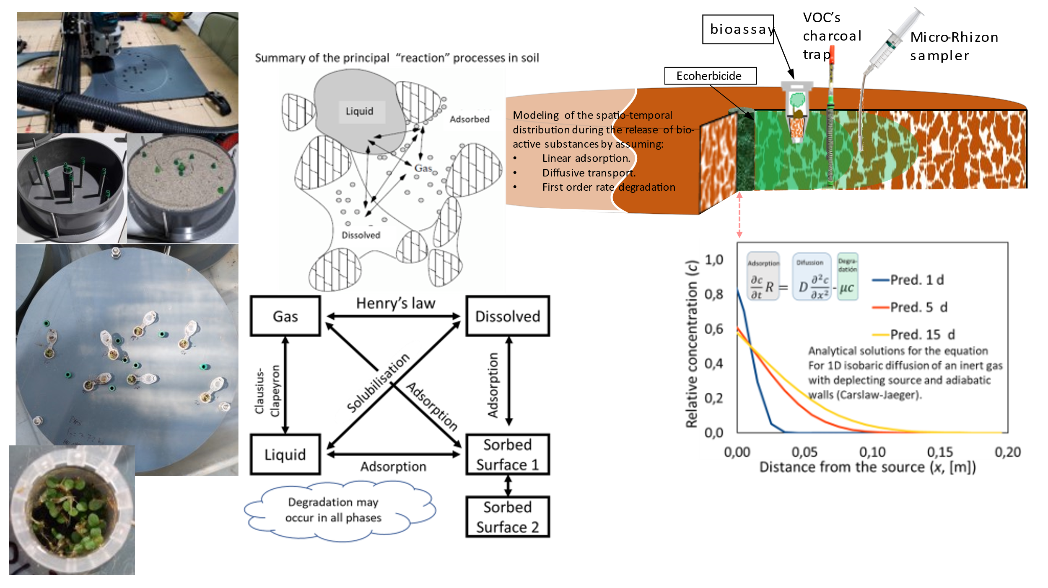

Figure 2.Schematics of the experimental setup for studying the transport of the bioactive VOCs and phenols, and 3D axysimmetric convective-difussive reactive transport modelling (Milestone 2, task 2.3).

Figura 3. Caption of the AVIZO-XLab interface during the calculation of the impedance factor for diffusivity on a binarised high resolution 3D image (3 microns) of a ecoherbicide pellet. Solid is represented in blue.